**Exercise 6**

1. **Display all the Suppliers with the same Status as the supplier, ‘CLARK’.**

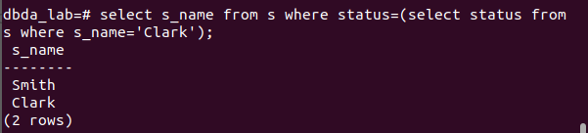

1. **Display all the Employees in the same department as the employee ‘MILLER’.**
2. **Display all the Parts which have more Weight than all the Red parts.**

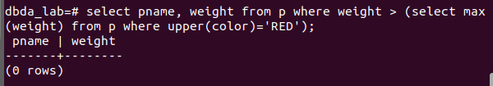

1. **Display all the Projects going on in the same city as the project ‘TAPE’.**
2. **Display all the Parts with Weight less than all the Green parts.**

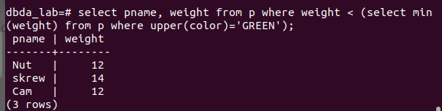

**6. Display the name of the Supplier who has sold the maximum Quantity (in one**

**sale).**

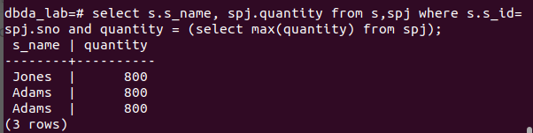

**7.Display the name of the Employee with the minimum Salary.**

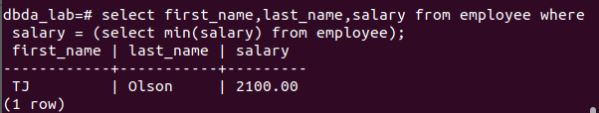

**8. Display the name of the Supplier who has sold the maximum overall Quantity (sum**

**of Sales).**

**9. Display the name of the Department with the maximum number of Employees.**